MTH 200 | Integration

Directions: Solve all problems on a separate sheet(s) of paper. Place your name on the pages you submit. You must show all of your work to receive full credit on problems. You must write complete sentences when asked to show/prove something or provide an explanation/justification. You are encouraged to work with others, consult sources, use calculators, etc. However, only submit solutions that you fully understand. Do not submit solutions which are copied from a friend or another source.

Challenge Questions

Integration
- Consider the definite integral .
- Sketch what is graphically represented by this integral.
- Use geometry to calculate this integral.
- Show that this integral equals 12 using the limit definition of the definite integral.

- Consider the definite integral .
- Compute the value of the integral using geometry.
- Compute the value of the integral using the FTOC.
- Compute the value of integral using the limit definition of the definite integral.

- Determine the value of the following limits by relating the limit to a definite integral over the specified interval. (Use right endpoints.)
- over .

- Evaluate the following limit. Be sure to use proper notation throughout your evaluation.

- Let .
- Use your calculator to graph this function on the interval .
- Compute by first solving the integral and then differentiating.
- Compute by using the FTCP1 directly.
- Show that that the two results from parts (b) and (c) are consistent.

- Compute the maximum of the function .

INTEGRALS AND AVERAGE VALUES
- Compute the following limit

Note that

We note that . Therefore, we have that

- Compute

- The function is defined on by . Show that and use this to determine after computing the value of H at .

We calculate that and then

We therefore know that since then .
So, we compute and this means that
This means that . This implies that .

RATES OF CHANGE
- A point is moving along the x-axis with acceleration at time t. If its initial velocity is 27, how far does the particle move from time to time ?
- A patient is experience blood loss at a rate of pints per minute at time t (as t increases, the blood loss slows due to decreased pressure). Approximately how long before the patient loses 3 pints of blood after ?

- During a race, the velocities of two cars were plotted, and . After the first hour, car A was ahead of car B but car B finished the race in 2 hours, which was 15 minutes (0.25 hours) ahead of car A. From this information we can say… (fill in in the space)

SUBSTITUTIONS
Worksheet 23.

General Review

FINAL REVIEW
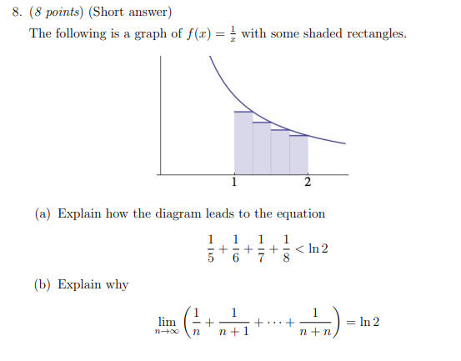

- Let where h and b represent arbitrary positive real numbers.

- Sketch the graph of being sure to label the x-intercepts and y-intercepts.

The y-intercept of a function occurs when , therefore the y-intercept for f is .
The x-intercept(s) of a function occurs when , therefore the x-intercepts for f are
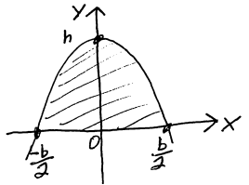
.

Therefore, a sketch of would look like the picture at the right.

- Determine the area of the finite region bounded by the graph of and the x-axis. Fully simplify your answer.

We calculate

Thus, the area of a parabolic arch is .

- Suppose that , is continuous, and , what is the value of ?
We know that and since we are given that this means that .
We also are told that and therefore

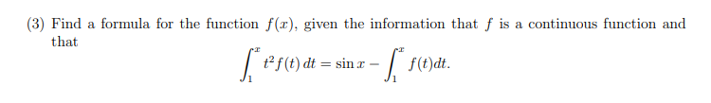

- Consider the following three functions.
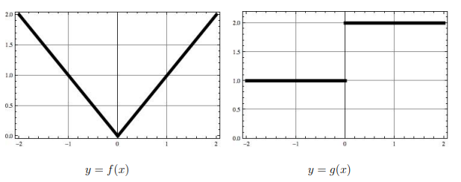

- Which of the functions are continuous?

We see that is continuous and we know that is continuous by the FTCP1.
is not continuous at .

- Which of the functions are differentiable?

We see that and are not differentiable at .
We know that is differentiable by the FTCP1.

- What is equal to?

We know that

- What is equal to?
We know that

- What is

We calculate that
- What is equal to?

We calculate this value geometrically by looking at the graph of

- What is equal to?

We calculate that and so

Derivatives
- Give an example where and are increasing at but is decreasing at .

